Problem Set 5
(100 points)

Problem 1 – Pricing in the Market for Air Taxis (20 points)

- (4 points) Provide an estimate of marginal costs (MC) for the trip.

The distance as the crow flies between LAX and downtown LA is 12 miles (see e.g., freemaptools.com).

Costs for the trip= 3x12=$36

The marginal costs for the trip will amount to $36.

- (10 points) For each of these four passenger types, estimate the average willingness to pay for the trip and then plot these values in a graph.

To compute the average willingness to pay for each passenger type we consider each type’s opportunity cost of time. By switching from a regular taxi to an air taxi a passenger may save 30 minutes of commuting time.

  - Assuming an average hourly rate of $238 (see e.g., salary expert), 30 minutes are worth $119 to a CEO. Hence, the CEO should be willing to pay $169 (=50+119) for the trip.
  - Assuming an average hourly rate of $100 for other business travelers, 30 minutes are worth $50 to them. Other business travelers should be willing to pay $100 for the trip.
  - An hour of city tour through downtown is worth, on average, $25. Hence, 30 minutes are worth $12.5 and a tourist should be willing to pay $62.5 for the trip.
  - The average student hourly rate is $18. Hence, 30 minutes are worth $9 and a student should be willing to pay $59 for the trip.

Note: Your assumptions may deviate from the ones above, which is fine as long as your reasoning is coherent.

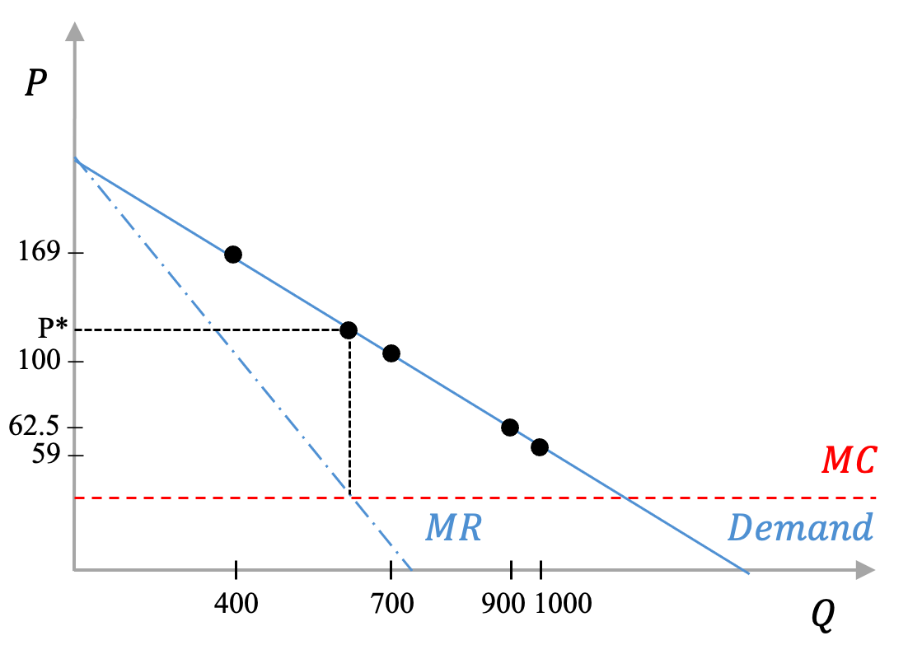
- (6 points) Give an example of a pricing strategy that could incentivize the different passengers to pay different prices.

To extract more surplus from its customer base, Joby could offer a menu of differential services such that different passenger types select different ride experiences. For instance, a single-customer ride with luxurious amenities and additional services may be offered at a premium rate along with a basic multiple-customers, shared ride experience at a cheaper rate. The set of prices should be incentive compatible such that CEO and other business travelers would be better off choosing the premium ride experience, while tourists and students would prefer the standard shared-ride experience at the cheaper rate. This pricing strategy is referred to as versioning or second-degree price discrimination. The company tries to discriminate between different consumers by inducing consumers with different willingness to pay to choose different versions of their products. Ideally, Joby would offer four versions of ride experiences, each for each of the four passenger types.

Problem 2 – Two-part pricing (25 points)

- (8 points) What subscription fee and usage price would you charge for business customers? What would be your profits from a typical business customer?

You should charge a usage price equal to marginal cost: P=2. At this price, a business customer would use Q=10-2=8 days of computing. Then, for business customers, consumer surplus is
$$8⋅\left(10-2\right) ⋅\frac{1}{2}=\$32$$
Therefore, you’d charge F=$32 per month and $2 per day in usage price. This leaves zero consumer surplus after paying the subscription fee. Each business customer will yield a profit of $32 per month.
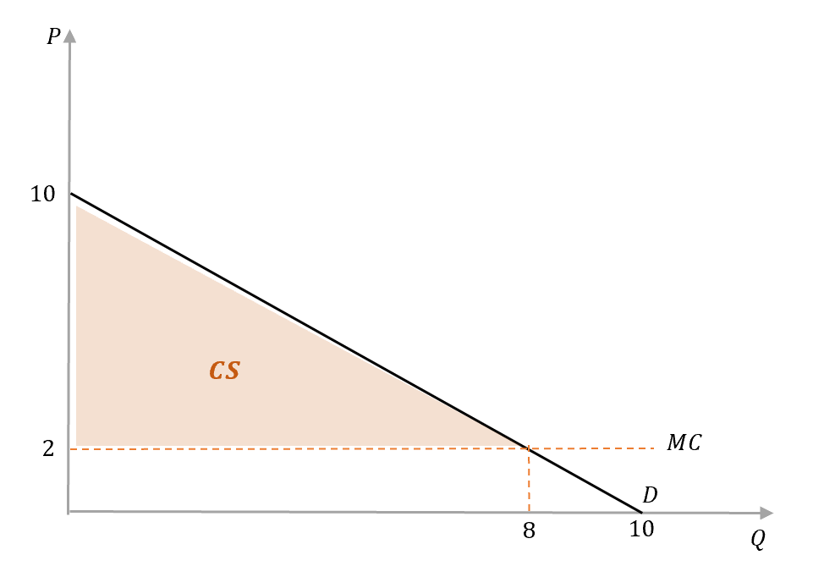

- (6 points) Suppose you are initially only offering the business option of the software (i.e., at the F and P computed in a). Would a typical academic customer buy that option? Why or why not? Hint: compute the consumer surplus of academic users under the pricing scheme for business customers.

At a usage price of $2, an academic customer would use Q=8-2=6 days of computing. The consumer surplus of an academic customer would be
$$6⋅\left(8-2\right) ⋅\frac{1}{2}=\$18$$
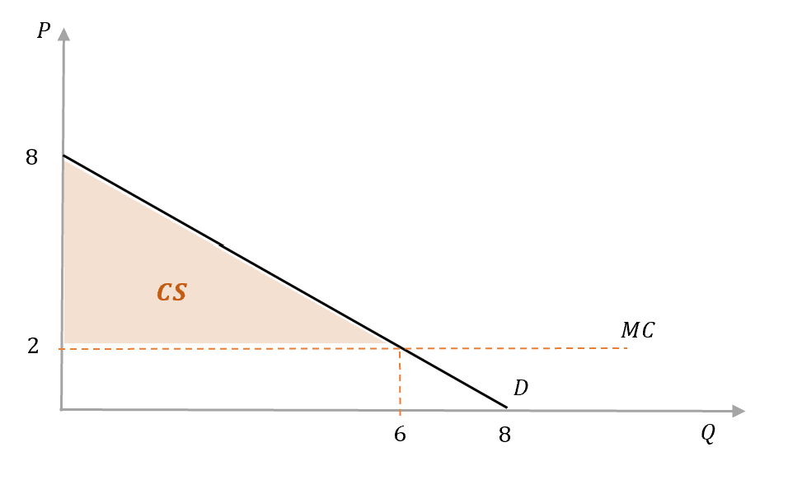
Since $18 consumer surplus is below the subscription fee of $32 for business customers, academics would not subscribe to your service. That is, you would lose out on that market.

- (5 points) After taking a class on complex pricing, you create a special deal for people who can show proof for an academic affiliation. What F and P would you charge for academic customers? What would be your profits from a typical academic customer?

You would charge P=2 and F=18 (i.e., the consumer surplus computed under b) to academics. Your profit from this group would then be $18 per customer.

- (4 points) Which two complex pricing strategies does your new pricing scheme combine?

The pricing scheme combines a two-part tariff and segment pricing (distinguishing between academic/business customer segments).

- (2 points) If you do not ask for proof of an academic affiliation, which problem can arise with your pricing scheme? Hint: What would business customers do if they learn about the academic deal?

Business customers would also purchase the academic version since it has the same usage price, but a lower subscription fee.

- (5 points) Give an example of similar pricing scheme from your work experience or an industry you know closely. Does it face the same problem as the one you described in (e)? If yes, how is it circumvented? If not, why is it not circumvented?

In this solution we give an example that is different from the academic affiliation discount mentioned above. For instance, movie theaters offer senior discounts on tickets, charging lower prices to customers above a certain age. This creates the same issue as in (e), since younger customers would prefer to pay the cheaper senior rate. The problem is avoided by theaters requesting customers to show a government-issued ID to confirm age at the movie theater entry, preventing younger individuals from using the discounted ticket.

Problem 3. Duopoly (35 points)

Two identical firms produce an identical product, and they are the only firms in this market. Their total annual costs are given by TC₁ = 300+15q₁ and TC₂ = 200+25q₂, where q₁ is the output of firm 1, and q₂ is the output of firm 2.

Price is determined by the following industry demand curve:

P = 110 - Q

where Q = q₁ + q₂.

Each firm decides how much to produce taking as given the output decision of the other

a. (1 point) Which type of competition do the two firms engage in?

Cournot Competition

b. (7 points) Derive the reaction function for each firm. Explain what these curves mean.

To derive the reaction functions we need to calculate $MC=MR$ for both producers. By taking derivatives form $TC$ we get:

$${MC}_{1}=15$$
$${MC}_{2}=25$$

Marginal Revenues are derived as follows:

$${TR}_{1}=P{∙q}_{1}=110q_{1}-q_{2}q_{1}-{q_{1}}^{2}$$
$${TR}_{2}=P{∙q}_{2}=110q_{2}-q_{1}q_{2}-{q_{2}}^{2}$$

$${MR}_{1}=110-q_{2}-{2q}_{1}$$
$${MR}_{2}=110-q_{1}-{2q}_{2}$$

Computing $MC=MR$ and solving for $q_{1}$ and $q_{2}$ we get:

Firm 1: $110-q_{2}-{2q}_{1}=15→2q_{1}=95{-q}_{2}$
$$q_{1}=47.5-0.5q_{2}$$
Firm 2: $110-q_{1}-{2q}_{2}=25→2q_{2}=85{-q}_{1}$
$$q_{2}=42.5-0.5q_{1}$$

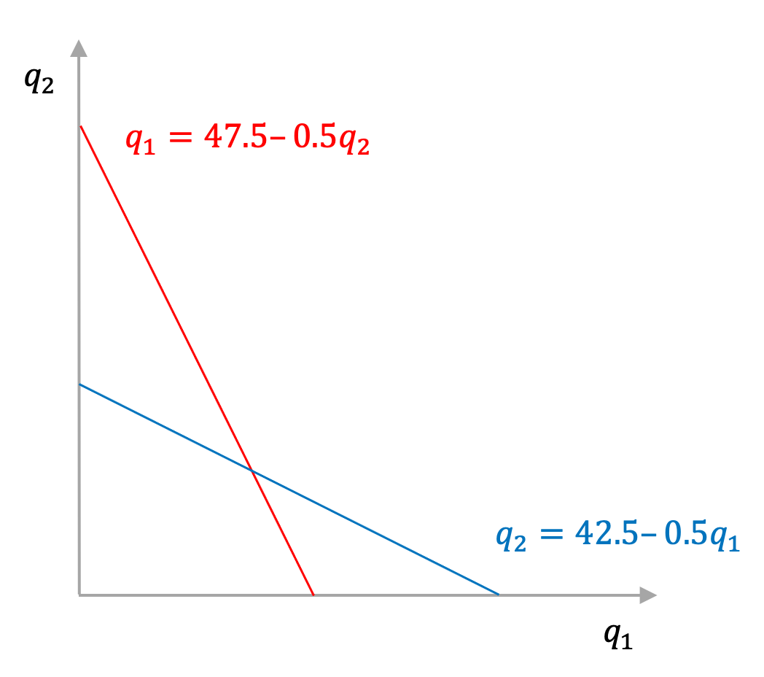
These curves depict a function that returns the optimal (profit-maximizing) quantity that a firm should produce, given any quantity produced by its competitor. For instance, for firm 2, the reaction function pinpoints in the y-axis what is the optimal q2 that firm 2 should produce for each q1 produced by firm 1 (given in the x-axis).

c. (7 points) Find the equilibrium quantities and the price. Calculate the profit of each firm in equilibrium.

To find the solution we plug $q_{2}$ into $q_{1}$.

$$q_{1}=47.5-0.5\left(42.5-0.5q_{1}\right)$$
$$q_{1}=26.25+0.25q_{1}$$
$$q_{1}=35$$
And therefore:
$$q_{2}=42.5-0.5q_{1}=42.5-0.5\left(35\right)=25$$

$$Q=q_{1}+q_{2}=60$$
$$P=110-Q=110-60=50$$

$$Π_{1}=P{∙q}_{1}-{TC}_{1}=50*35-\left(300+15*35\right)=925$$
$$Π_{2}=P{∙q}_{2}-{TC}_{2}=50*25-\left(200+25*25\right)=425$$

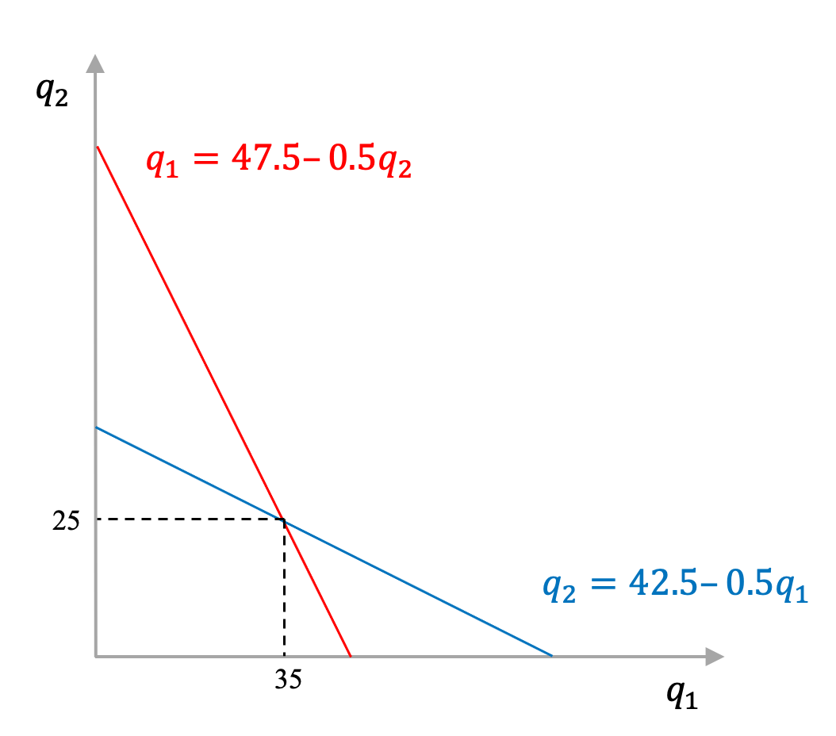

d. (2 points) It turns out that the land on which firm 2 has been built is legally owned by Don, who offers to rent the land to firm 2 for 500 per period. That is, this cost would occur in addition to all previously mentioned costs of firm 2. How would this be represented in firm 2’s total cost function?

The rent for the land is a fixed cost: TC₂ = 500+200+25q₂ = 700+25q₂

e. (4 points) A court rules that firm 2 has to pay the rent for this year regardless whether or not it produces. Will firm 2 still produce this year? If so, what is the optimal quantity produced?

The average variable cost is equal to 25, which is lower than the price ($P=50$). By continuing production, Firm 2 thus positively contributes to covering its fixed costs. Another way of seeing this is to compute profits under the two situations: profits would be -700 (i.e., the full fixed cost) if it stopped producing now, whereas it would be $π_{2}=50*25-\left(700+25*25\right)=-75$ if it keeps on producing.

The quantity produced by firm 2 does not change because the rental cost is fixed and thus does not affect the equilibrium price and quantity. So firm 2 stills produces 25 units.

f. (3 points) The court also rules that starting next year, the firm would not have to pay the rent if it declared bankruptcy. Thus, ‘next year’ can be considered the long run, when no fixed costs occur if the firm goes out of business [this includes all fixed costs, not only the rent]. Will the firm produce next year?

Since profits (after accounting for the rental cost of 500 and other fixed cost of 200) are -75, firm 2 will exit the market next year when it has the possibility to do so. Alternatively, you can compare the price to the ATC at $q_{2}=25$: $ATC_{2}=\frac{TC_{2}}{q_{2}}=\frac{700}{q_{2}}+25=\frac{700}{25}+25=53$. Thus, $P<ATC$, so the firm makes negative profits and should exit the market in the long run.

g. (6 points) Suppose that we are in the second year now and firm 2 exits the market for good, so that firm 1 is the only producer. Calculate its optimal output $q_{1}^{*}$, the new market price, and profits. Relate your findings to the graph that you computed under question b).

Firm 1 is now a monopoly in the market:

$${TR}_{1}=P∙q_{1}=110q_{1}-{q_{1}}^{2}$$
$${MR}_{1}=110-2q_{1}$$
$${MC}_{1}=15$$

$${MR}_{1}={MC}_{1}$$
$$110-2q_{1}=15$$
$${2q}_{1}=95$$
$$q_{1}=47.5$$

$$P=110-q_{1}=62.5$$
$Π_{1}=P{∙q}_{1}-{TC}_{1}=62.5*47.5-\left(300+15*47.5\right)=1956.3$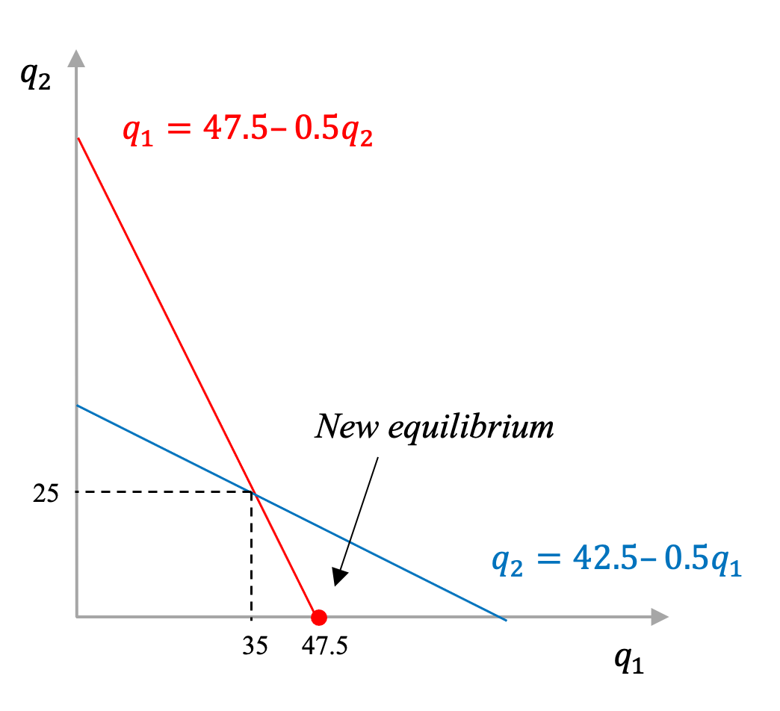

h. (6 points) Compute consumer surplus under the scenario with two firms (c.) and only firm 1 (g.). Did Don do consumers a favor by demanding high land rental payments and pushing firm 2 out of business? Explain. [Note: graphs are not required for full credit but they can be useful to see how to compute the CS under the two scenarios]

${CS}_{c}=1/2\left(110-P\right)Q=0.5*60*60=1,800$
${CS}_{f}=1/2\left(110-P\right)Q=0.5*47.5*47.5=1,128.1$
P
Q
110
P = 50
Q
= 60
P
Q
110
P = 62.5
Q
= 47.5
Consumer Surplus under c.
Consumer Surplus under f.
Consumers are worse off under f. with only one producer.

i. (4 points) Let’s go back to the initial setup (i.e., the problem described before question A.) Suppose that the two firms compete by setting prices. How is this competition called, and what is the most likely outcome (market price and total quantity produced)? [assume there’s no collusion]
Note/hint (for 1 point): If one firm becomes the only producer for a certain price range, use your answer from g) to check whether it may want to charge an even lower price to maximize its profits.

This is Bertrand competition. Firm 1 will set $P=24.99$ (just below Firm 2’s marginal cost), which will just push firm 2 out of the market. Total quantity will be: Q=110-P₁=85.01. Would Firm 1 potentially want to set an even lower price, since it is a monopolist at any $P_{1}<25?$ The answer is: no. As we have seen in g), a monopolist would produce $q=47.5$, implying a market price $P=62.5$. Thus, if anything, Firm 1 would want to charge a price above $25. But that, in turn, would bring Firm 2 back into the market. So $P=24.99$ is the optimal price for Firm 1.

Problem 4. Price wars (15 points)

a. (10 points) The newspapers set their advertising rates independently. Determine the optimal strategy for each firm. Is there a dominant strategy for any of the two firms? If so, explain why.

Each firm wants to maximize their profit. Firm A will always choose the “Low Ad Rate”, independent of Firm B’s choice. And vice-versa, Firm B will always choose the “Low Ad Rate,” independent of Firm A’s choice. Thus, the “Low Ad Rate” strategy is dominant for both firms.
Explanation (see also the arrows below):
- If firm B chooses High Ad Rate, firm A will choose Low Ad Rate because it will give firm A 26 (>20). If firm B chooses Low Ad Rate, firm A will choose Low Ad Rate because it will give firm A 15 (>10).
- If firm A chooses High Ad Rate, firm B will choose Low Ad Rate because it will give firm B 26 (>20). If firm A chooses Low Ad Rate, firm B will choose Low Ad Rate because it will give firm B 15 (>12)

 |  | FIRM B
 |  | High Ad Rate | Low Ad Rate
FIRM A | High Ad Rate | 20, 20 | 10, 26
 | Low Ad Rate | 26, 12 | 15, 15

b. (5 points) What is the Nash equilibrium of this game and the payoff for each firm?

The Nash equilibrium of this game is {Firm A plays “Low Ad Rate,” Firm B plays “Low Ad Rate”}. The payoff for each firm is 15.

